

**Caring for Your Oboe**

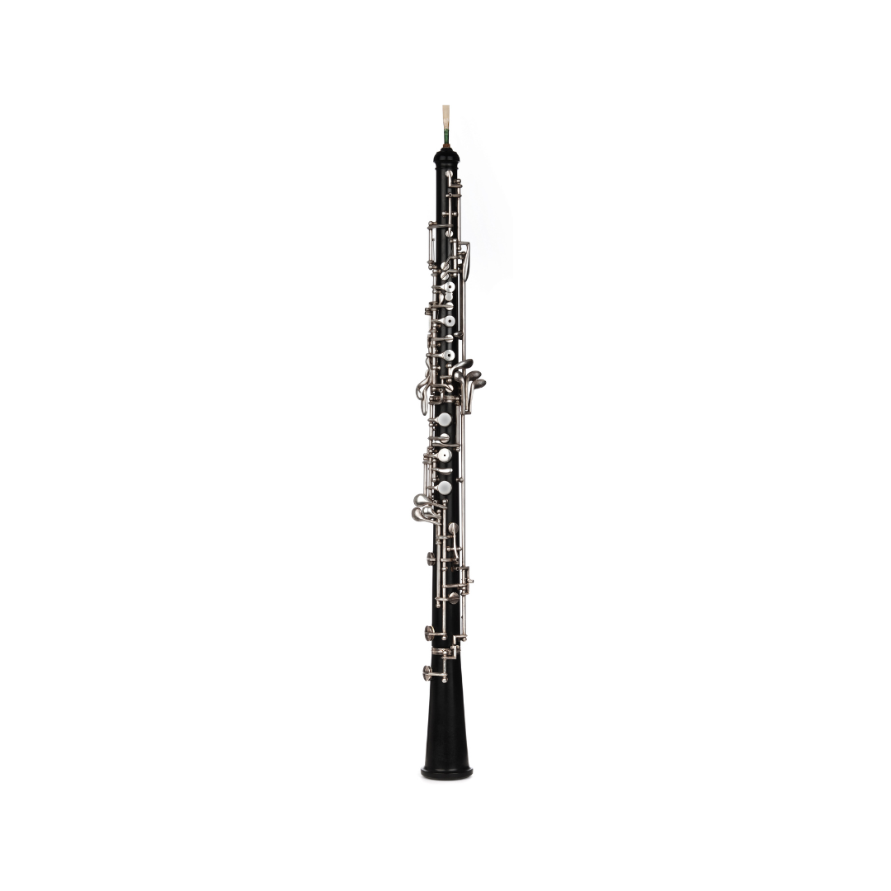

**What to do**

* Take the oboe apart carefully and clean the inside after playing with a cloth.
* Store reeds in a reed case.
* Put the oboe in its case and close it when not in use.
* Keep the instrument dry and clean; let a teacher show you how to oil corks.

**What not to do**

* Don’t force joints together.
* Don’t leave the reed on the oboe when not in use.
* Don’t leave it where it can get knocked over.
* Don’t try to adjust the keys by yourself.