
Caring for Your Saxophone
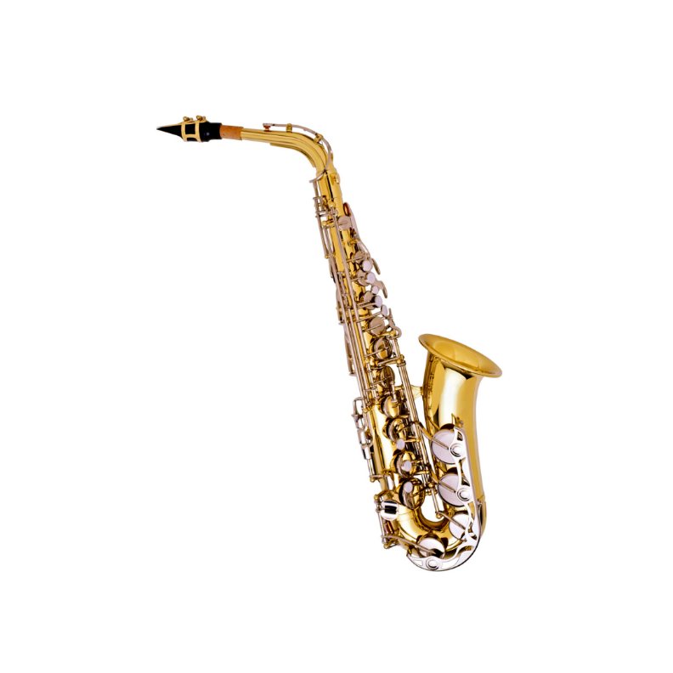
What to do
- Take the Saxophone apart and dry the inside with a cloth after playing.
- Keep the reed in a reed case and change reeds regularly.
- Put the Saxophone in its case and close it when not in use.
- Oil the corks sometimes (ask your teacher for the right oil).
- Check the keys gently for loose screws.
What not to do
- Don’t leave the reed on the mouthpiece when you put it away.
- Don’t force joints together — line them up and push gently.
- Don’t eat or drink (except water) before playing.
- Don’t try to fix broken keys yourself.

