

**Caring for Your Bassoon**

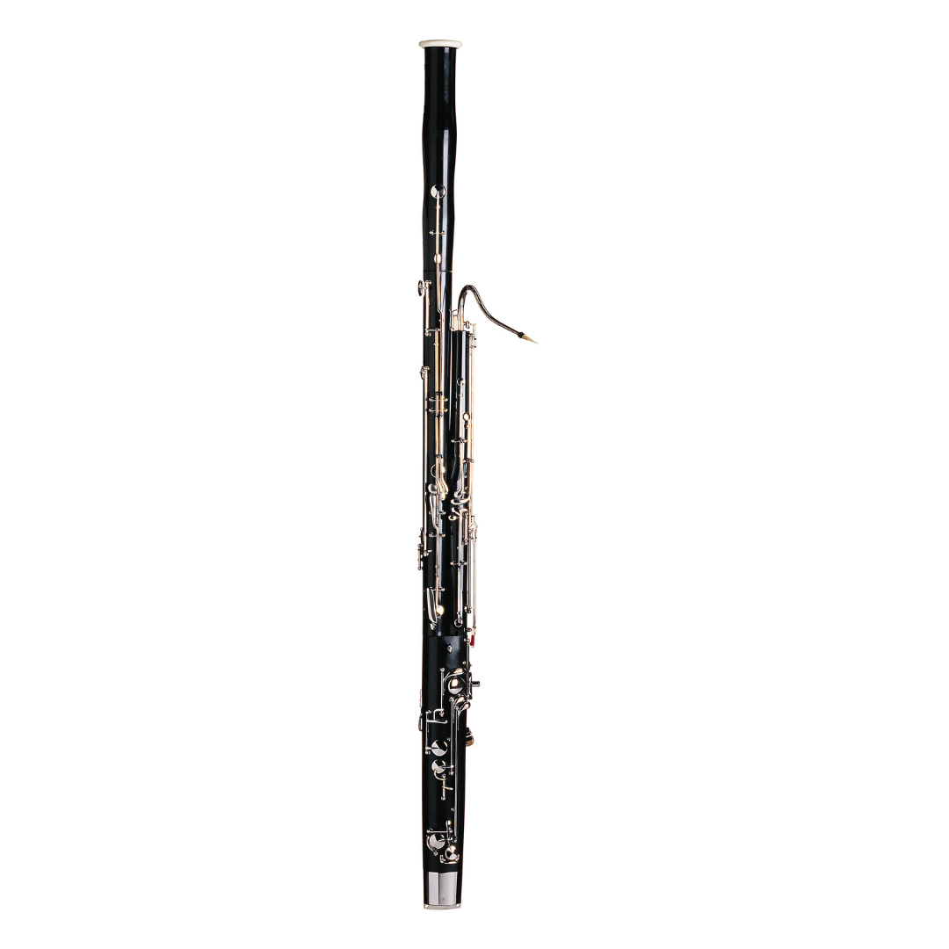

**What to do**

* Take the bassoon apart carefully and dry each section with a cloth.
* Store the reed and bassoon safely.
* Keep the bassoon in its case and close the latches or zipper.
* Handle the joints gently and line them up before assembling.

**What not to do**

* Don’t bang or drop the bassoon.
* Don’t put heavy items on the case.
* Don’t try to bend the bassoon or fix cracks yourself.
* Don’t leave it where it is very hot or damp.