

**Caring for Your French Horn**

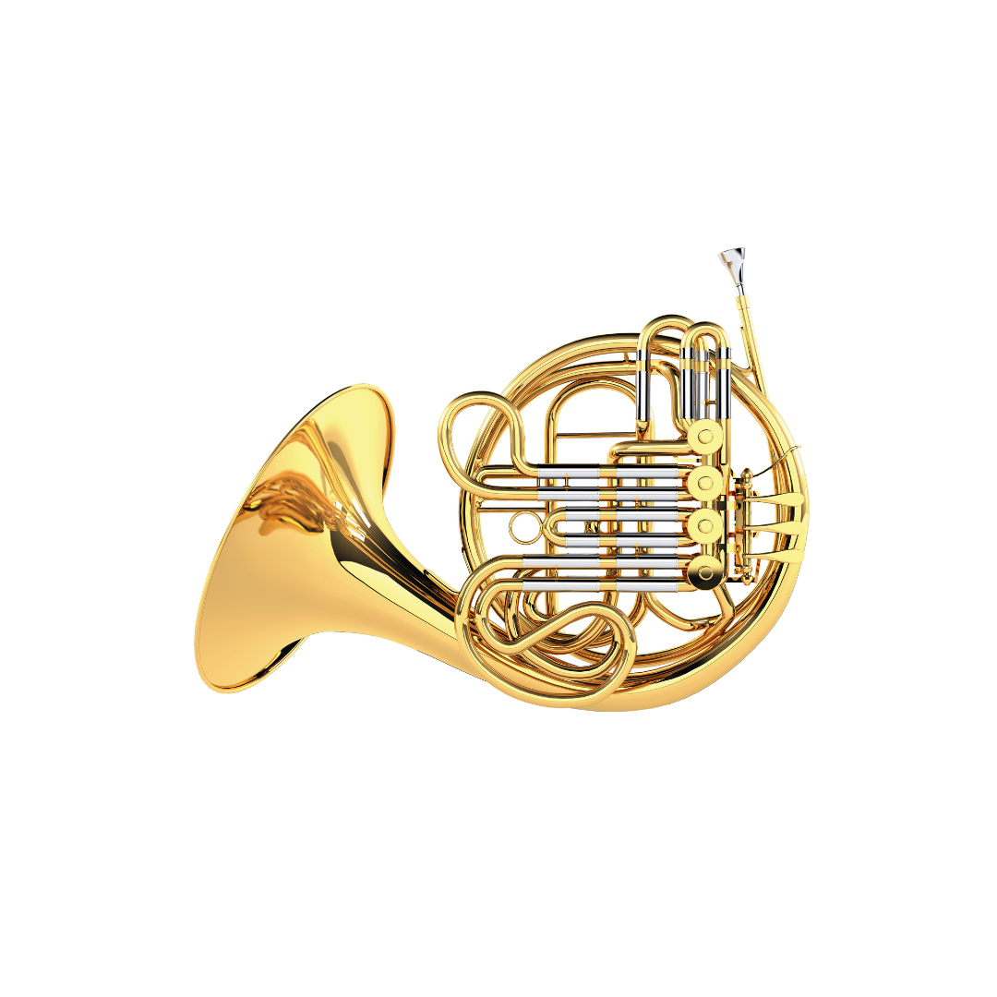

**What to do**

* Store the horn in its case when not playing.
* Wipe outside with a dry cloth after playing.
* Remove and clean the mouthpiece.
* Oil the valves as needed, following teacher instructions.
* Keep the horn in a safe place so it does not roll or fall.

**What not to do**

* Don’t put heavy things on the case.
* Don’t push the valves too hard.
* Don’t leave water inside the horn—empty water keys.
* Don’t try to fix dents or problems with the horn yourself.