Croydon Music and Arts
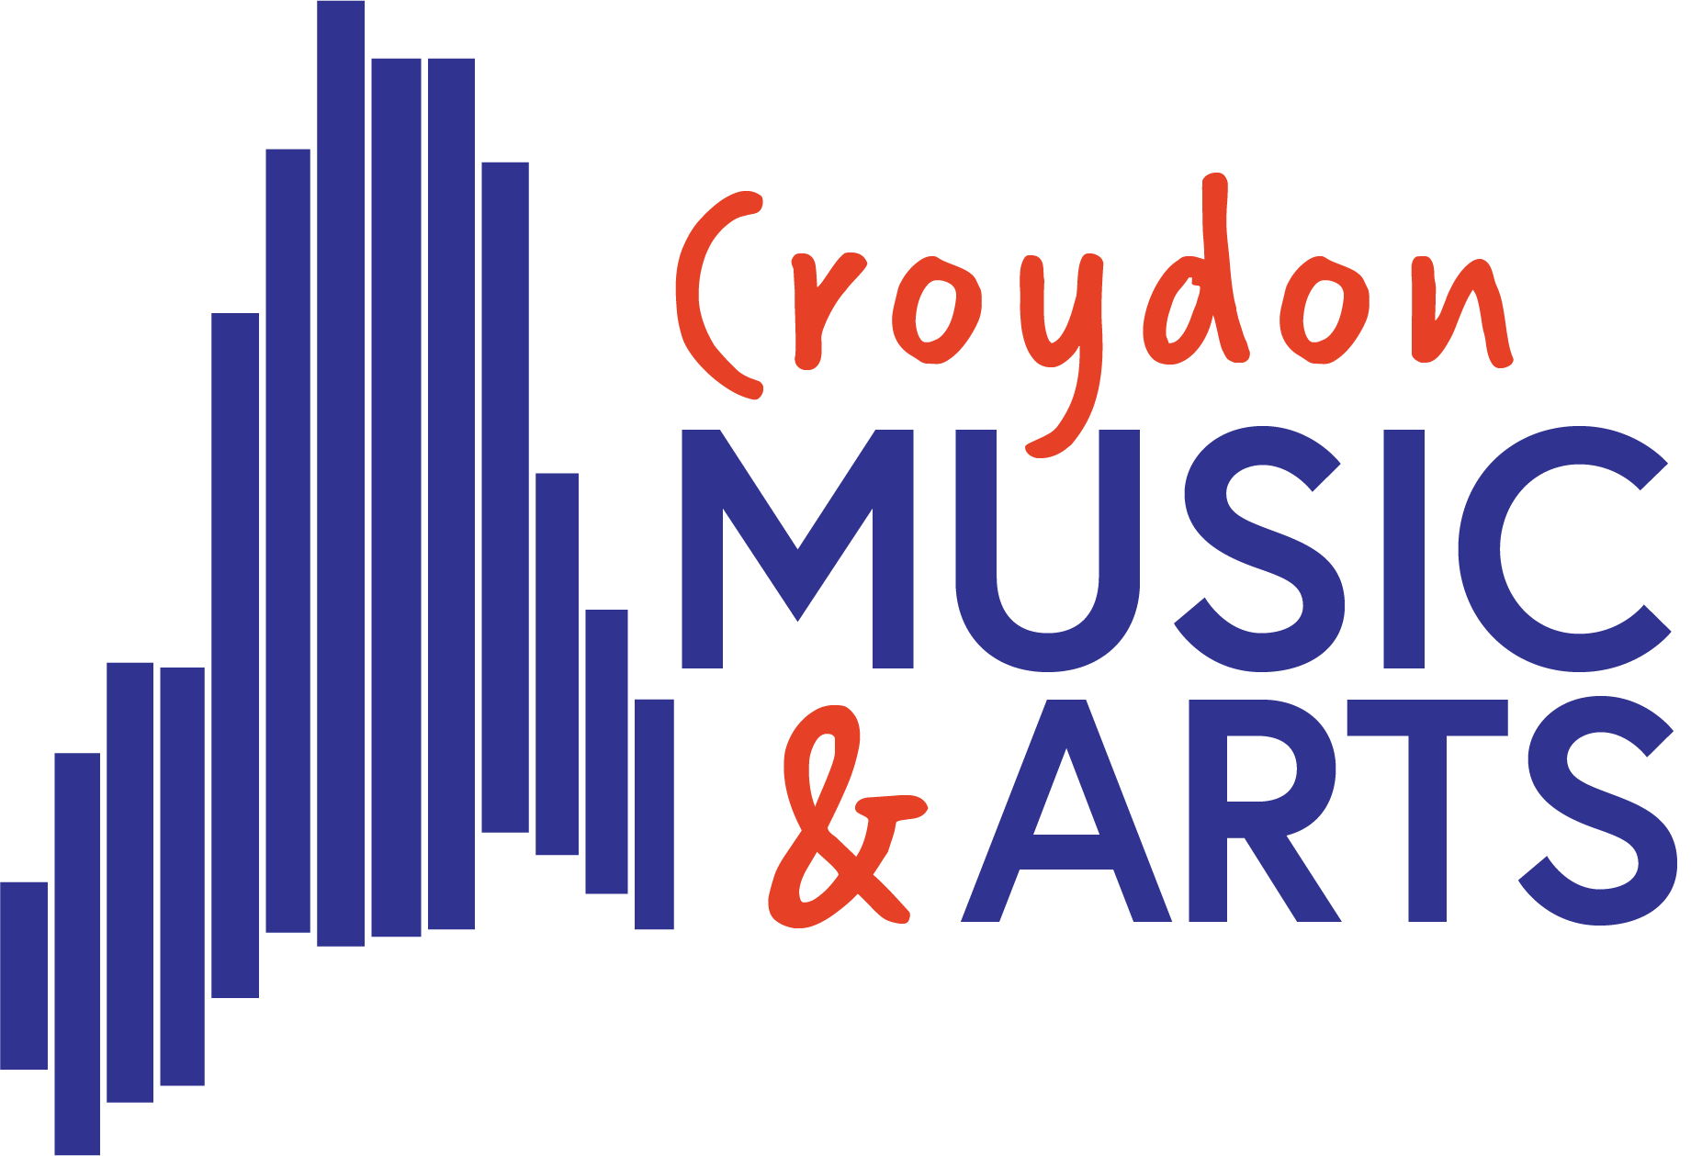
Allergy and anaphylaxis policy

Version | Date | Author/Owner | Summary of Changes | Approved By
1 | 22/9/26 | IF | New policy

Purpose | To minimise the risk of any child suffering a serious allergic reaction whilst at organisation or attending any organisation related activity. To ensure staff are properly prepared to recognise and manage serious allergic reactions should they arise.
Links with other policies | Consider Health and Safety and Safeguarding
Review Frequency | 1 yearly or if an incident occurs (near miss or reaction)
Date of next review | 1 September 2027

The named staff members (at least 2) responsible for coordinating staff anaphylaxis training and the upkeep of the organisation’s anaphylaxis policy are:
Isabel Fixter and Lucie Vezey

Contents
- Introduction
- Roles and responsibilities
- Allergy action plans
- Emergency treatment and management of anaphylaxis
- Supply, storage and care of medication
- ‘Spare’ adrenaline auto-injectors in organisation
- Staff training
- Inclusion and safeguarding
- Food
- Trips
- Allergy awareness and nut bans
- Risk assessment
- Useful links

Introduction

An allergy is a reaction of the body’s immune system to substances that are usually harmless. The reaction can cause minor symptoms such as itching, sneezing or rashes but sometimes causes a much more severe reaction called anaphylaxis.

Anaphylaxis is a severe, life-threatening allergic reaction. The whole body is affected often within minutes of exposure to the allergen, but sometimes it can be hours later. Causes can include foods, insect stings, and drugs.

Most healthcare professionals consider an allergic reaction to be anaphylaxis when it involves difficulty breathing or affects the heart rhythm or blood pressure. Anaphylaxis symptoms are often referred to as the ABC symptoms (Airway, Breathing, Circulation).

It is possible to be allergic to anything which contains a protein, however most people will react to a fairly small group of potent allergens.

Common UK Allergens include (but are not limited to): Peanuts, Tree Nuts, Sesame, Milk, Egg, Fish, Latex, Insect venom, Pollen and Animal Dander.

This policy sets out how Croydon Music and Arts will support children with allergies, to ensure they are safe and are not disadvantaged in any way whilst taking part in organisation life.

Role and responsibilities

Parent Responsibilities
  - On entry to the organisation, it is the parent’s responsibility to inform the manager of any allergies. This information should include all previous serious allergic reactions, history of anaphylaxis and details of all prescribed medication.
  - Parents are to supply a copy of their child’s Allergy Action Plan (BSACI plans preferred) to the organisation. If they do not currently have an Allergy Action Plan this should be developed as soon as possible in collaboration with a healthcare professional e.g. GP/allergy specialist.
  - Parents are responsible for ensuring any required medication is supplied, in date and replaced as necessary.
  - Parents are requested to keep the organisation up to date with any changes in allergy management. The Allergy Action Plan will be kept updated accordingly.

Staff Responsibilities
  - All staff¹ will complete anaphylaxis training. Training is provided on a yearly basis and on an ad-hoc basis for any new members of staff.
  - Staff (regular or cover) must be aware of the children in their care who have known allergies as an allergic reaction could occur at any time and not just at mealtimes. Any food-related activities must be supervised with due caution.
  - Staff leading organisation trips² will ensure they carry all relevant emergency supplies. Trip leaders will check that all children with medical conditions, including allergies, carry their medication. Children unable to produce their required medication will not be able to attend the excursion.
  - The Business Manager/First Aider will ensure that the up-to-date Allergy Action Plan is kept with the child’s medication.
  - The Business Manager/First Aider keeps a register of children who have been prescribed an adrenaline auto-injector (AAI) and a record of use of any AAI(s) and emergency treatment given.

Child Responsibilities
  - Children are encouraged to have a good awareness of their symptoms and to let an adult know as soon as they suspect they are having an allergic reaction.
  - Children who are trained and confident to administer their own AAIs will be encouraged to take responsibility for carrying them on their person at all times.

Allergy Action Plans

Allergy action plans are designed to provide medical and parental consent for organisations to administer medicines in the event of an allergic reaction, including consent to administer a spare adrenaline auto- injector.

Organisations should not be devising their own allergy action plans but requiring parents to provide the plan created by the GP or allergy clinic.

Emergency Treatment and Management of Anaphylaxis

What to look for:
Symptoms usually come on quickly, within minutes of exposure to the allergen. If symptoms do not come on quickly, the child must be monitored for a delayed reaction. Additionally, they should not exercise for the remainder of the day unless medical advice has been sought and permission given.

Mild to moderate allergic reaction symptoms may include:
- a red raised rash (known as hives or urticaria) anywhere on the body
- a tingling or itchy feeling in the mouth
- swelling of lips, face or eyes
- stomach pain or vomiting.

More serious symptoms are often referred to as the ABC symptoms and can include:
- AIRWAY - swelling in the throat, tongue or upper airways (tightening of the throat, hoarse voice, difficulty swallowing).
- BREATHING - sudden onset wheezing, breathing difficulty, noisy breathing.
- CIRCULATION - dizziness, feeling faint, sudden sleepiness, tiredness, confusion, pale clammy skin, loss of consciousness.

The term for this more serious reaction is anaphylaxis. In extreme cases there could be a dramatic fall in blood pressure. The person may become weak and floppy and may have a sense of something terrible happening. This may lead to collapse and unconsciousness and, on rare occasions, can be fatal.

If the child has been exposed to something they are known to be allergic to, then it is more likely to be an anaphylactic reaction.

Anaphylaxis can develop very rapidly, so treatment is needed that works rapidly. Adrenaline is the mainstay of treatment, and it starts to work within seconds.

What does adrenaline do?
- It opens up the airways
- It stops swelling
- It raises the blood pressure

As soon as anaphylaxis is suspected, adrenaline must be administered without delay. Action:
- Keep the child where they are, call for help and do not leave them unattended.
- LIE CHILD FLAT WITH LEGS RAISED – they can be propped up if struggling to breathe but this should be for as short a time as possible.
- USE ADRENALINE AUTO-INJECTOR WITHOUT DELAY and note the time given. AAIs should be given into the muscle in the outer thigh. Specific instructions vary by brand – always follow the instructions on the device.
- CALL 999 and state ANAPHYLAXIS (ana-fil-axis).
- If no improvement after 5 minutes, administer second AAI.
- If no signs of life commence CPR.
- Call parent/carer as soon as possible.

Whilst you are waiting for the ambulance, keep the child where they are. Do not stand them up, or sit them in a chair, even if they are feeling better. This could lower their blood pressure drastically, causing their heart to stop.

All children must go to hospital for observation after anaphylaxis even if they appear to have recovered as a reaction can reoccur after treatment.

Supply, storage and care of medication

Depending on their level of understanding and competence, children will be encouraged to take responsibility for and to carry their own two AAIs on them at all times in a suitable bag/container.

For younger children or those not ready to take responsibility for their own medication, there should be an anaphylaxis kit which is kept within 5 minutes of them, not locked away and accessible to all staff.

Medication should be stored in a suitable container and clearly labelled with the child’s name. The child’s medication storage container should contain:
- Two AAIs i.e. EpiPen® or Jext®
- An up-to-date allergy action plan
- Antihistamine as tablets or syrup (if included on allergy action plan)
- Antihistamine as tablets or syrup (if included on allergy action plan)
- Spoon if required
- Asthma inhaler (if included on allergy action plan).

It is the responsibility of the child’s parents to ensure that the anaphylaxis kit is up-to-date and clearly labelled. The organisation should not require additional sets of medication to be left for them as the child should always have their medication with them.

Older children and medication
Older children and teenagers should, whenever possible, assume responsibility for their emergency kit under the guidance of their parents and organisation staff. However, symptoms of anaphylaxis can come on very suddenly, so organisation staff need to be prepared to administer medication if the young person cannot.

Storage
AAIs should be stored at room temperature, protected from direct sunlight and temperature extremes both hot and cold.

Disposal
AAIs are single use only and must be disposed of as sharps. Used AAIs can be given to ambulance paramedics on arrival or can be disposed of in a pre-ordered sharps bin. Sharps bins to be obtained from and disposed of by a Vinci Facilities (site Facilities team)

‘Spare’ adrenaline auto-injectors in the organisation

Schools are able to purchase spare AAIs for emergency use in children who are risk
of anaphylaxis, but their own devices are not available or not working (e.g. because they are out of date) or are experiencing anaphylaxis for the first time. The legislation that allows this only applies to schools, however, if the organisation operates in a school, then with the school’s agreement the spare AAIs may be made accessible to the organisation for use after calling 999 and saying that spare AAIs are available. Croydon Music and Arts works with Oasis Academy Shirley Park so all site users have access to appropriately dosed spare AAIs.

Staff Training

The named staff members (at least 2) responsible for coordinating staff anaphylaxis training and the upkeep of the organisation’s anaphylaxis policy are: Isabel Fixter and Lucie Vezey

All staff will complete AllergyWise® allergy and anaphylaxis training³ annually, and on an ad-hoc basis during the induction of new staff.

AllergyWise® training includes:
- Knowing the common allergens and triggers of allergy
- Spotting the signs and symptoms of an allergic reaction and anaphylaxis. Early recognition of symptoms is key, including knowing when to call for emergency services
- Administering emergency treatment (including AAIs) in the event of anaphylaxis – knowing how and when to administer the medication/device
- Measures to reduce the risk of a child having an allergic reaction e.g. allergen avoidance, knowing who is responsible for what
- Managing allergy action plans and ensuring these are up to date
- A practical session using trainer devices (these can be obtained from the manufacturers’ websites: www.epipen.co.uk and www.jext.co.uk

Inclusion and safeguarding

Croydon Music and Arts is committed to ensuring that all children with medical conditions,
including allergies, in terms of both physical and mental health, are properly supported in organisation so that they can play a full and active role in organisation life, remain healthy and achieve their full potential within the organisation.

Food

The organisation needs to comply with legislation if it ever, even on a single occasion, provides food for its participants.

All food businesses must follow the Food Information Regulations 2014 which states that allergen information relating to the ‘Top 14’ allergens must be available for all food products. This means that when purchasing food the organisation is able to check the allergens before purchasing. Parents/Carers will be helpful in sharing what they are able to purchase when asked. This will make the provision of food much easier.

Should the organisation be planning food activities, camp, days out or celebratory events then the designated leader should meet with parents/carers at the earliest opportunity to discuss risks and control measures that will keep the child safe.

Unlabeled food poses significant risk of reaction and must never be given to children with allergies; for example, sweets brought into share with the group.

The organisation adheres to the following Department of Health guidance recommendations:

- Bottles, other drinks and lunch boxes provided by parents for children with food allergies should be clearly labelled with the name of the child for whom they are intended.
- If food is purchased from the organisation canteen/tuck shop, parents should check the appropriateness of foods by speaking directly to the catering manager.
- The child should be taught to also check with staff, before purchasing or eating food.
- Where food is provided by the organisation, staff should be educated about how to read labels for food allergens and instructed about measures to prevent cross contamination during the handling, preparation and serving of food. Examples include: preparing food for children with food allergies first; careful cleaning (using
warm soapy water) of food preparation areas and utensils. For further information, parents/carers are encouraged to liaise with the Manager.
- Food should not be given to food-allergic children without parental permission (e.g. parties, food treats).
- Use of food in crafts, cooking, science experiments and special events (e.g. celebrations, cultural events) needs to be considered and may need to be restricted/risk assessed depending on the allergies of particular children and their age.

Organisation trips

Staff leading trips will ensure they carry all relevant emergency supplies. Trip leaders will check that all children with medical conditions, including allergies, carry their medication. Children unable to produce their required medication will not be able to attend the excursion.

All the activities on the trip will be risk assessed to see if they pose a threat to allergic children and alternative activities planned to ensure inclusion.

Overnight organisation trips should be possible with careful planning and a meeting for parents/carer with the designated member of staff planning the trip should be arranged as early as possible. Staff at the venue for an overnight organisation trip should be briefed early on that an allergic child is attending and will need appropriate food (if provided by the venue).

Allergy awareness and nut bans

Croydon Music and Arts supports the approach advocated by Anaphylaxis UK towards nut
bans/nut free organisations. They would not necessarily support a blanket ban on any particular allergen in any establishment, including in organisations. This is because nuts are only one of many allergens that could affect children, and no organisation could guarantee a truly allergen free environment for a child living with food allergy. They advocate instead for organisations to adopt a culture of allergy awareness and education.

A 'whole organisation awareness of allergies' is a much better approach, as it ensures staff and children are aware of what allergies are, the importance of avoiding the child’s allergens, the signs & symptoms, how to deal with allergic reactions and to ensure policies and procedures are in place to minimise risk.

Croydon Music and Arts strongly discourages nut containing products into the learning environment as well as students sharing food privately while on site

Risk Assessment

Croydon Music and Arts will conduct a detailed individual risk assessment for all new joining
children with allergies and any child newly diagnosed, to help identify any gaps in systems and processes for keeping allergic children safe.

Useful Links

Anaphylaxis UK - https://www.anaphylaxis.org.uk/

- Safer Childcare Programme - https://www.anaphylaxis.org.uk/childcare/

- AllergyWise® for Wraparound Care and Holiday clubs online training: https://www.anaphylaxis.org.uk/product/allergywise-for-wraparound-care-and-holiday-clubs/

- AllergyWise® for clubs and youth organisations online training: https://www.anaphylaxis.org.uk/product/allergywise-for-clubs-and-youth-organisations/

- Allergy awareness V nut bans: The nut free debate

BSACI Allergy Action Plans - https://www.bsaci.org/professional- resources/resources/paediatric-allergy-action-plans/

Food allergy quality standards (The National Institute for Health and Care Excellence, March 2016) https://www.nice.org.uk/guidance/qs118

Anaphylaxis: assessment and referral after emergency treatment (The National Institute for Health and Care Excellence, 2020) https://www.nice.org.uk/guidance/cg134?unlid=22904150420167115834

Footnotes:
- It is strongly recommended that all staff complete allergy and anaphylaxis training to ensure that any member of staff can react quickly and accurately when a child has a reaction. When the training is limited to one or only a few members of staff, children with allergies are left in a potentially life-threatening situation if that member of staff is absence or deployed elsewhere.
- Trips are classed as any time the children leave the organisations usual place for any length of time; for example, a nature walk is considered a trip.
- AllergyWise® training is produced by Anaphylaxis UK, the only charity in the UK supporting those with severe allergies. The training is medically reviewed by leading allergy specialists.

