CMA Teacher Guidance for Teaching Lessons on Teams
Croydon Music and Arts
Safeguarding Policy and Guidance for Teachers

Version | Date | Author/Owner | Summary of Changes | Approved By
1 | 07/10/26 | JRegan | New policy

Safeguarding Requirements
- Teachers may only use their Croydon Council Microsoft Teams account to deliver online lessons. Personal accounts or alternative video platforms must not be used.
- A parent or carer must provide consent before online lessons commence. Where a Teams invitation is sent directly to a parent/carer and they facilitate the pupil attendance, this will be treated as implied consent.
- Include your line manager (or nominated manager) as an attendee on all online lesson invitations.
- All one-to-one online lessons must be recorded using Teams recording functionality.
- Usual CMA procedures relating to arrangement, attendance and cancellation of lessons continue to apply.
- Teachers and students should dress appropriately for lessons.
- Ensure that your background is appropriate.
- Do not share content on screen unless you have personally checked it is appropriate for the pupils you are teaching. This includes checking for audio with explicit language.
- Any safeguarding concern, disclosure, welfare concern or inappropriate online behaviour must be reported immediately.
- Teams lesson recordings will be retained for six months and staff must not download recordings to personal devices.
- Ensure you end the meeting for all participants at the conclusion of the lesson.
- For primary-aged pupils or pupils requiring additional support, parents/carers should remain nearby.
- Staff must maintain the same professional standards and boundaries as face-to-face teaching.

Good Practice
- Sound background: Teams will pick up conversations in the background. Ensure there are no personal or inappropriate conversations in the background for your lessons.
- Visual background: students will be interested in your background. Ensure all items in view are suitable for public broadcast.
- Teams sound settings must be set up correctly for a music lesson. The teacher and student should switch off noise suppression and switch on ‘High fidelity music mode.’
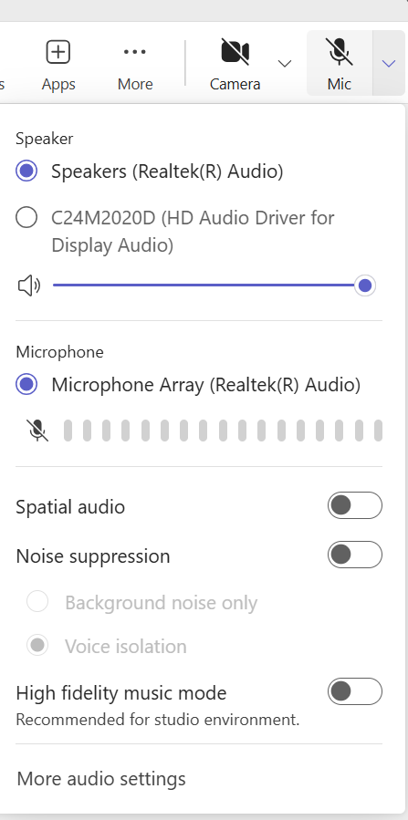
- It is the teacher’s responsibility to know how to do this in advance of the lesson so they can adjust their own settings and also instruct the student without using up lesson time unnecessarily. Be aware that Teams may provide updates so the wording and location of these features may change. The screenshot below shows where to find these options on the current version of Teams, under the microphone menu.

