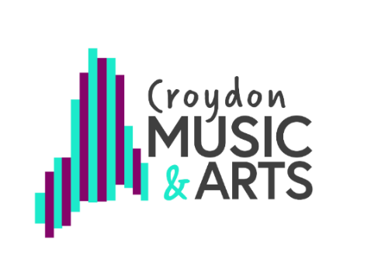
RSL Star Award (Star 3)

Assessment task: Research and share practice from a formal arts tradition.

Talk to your teacher and explore something related to what you have been learning recently.

Music: If you play an instrument (or sing) look at the pieces (or songs) you have been playing/ singing. Investigate the background of that style of music, for example Jazz, Blues, Classical, Sea Shanty, Indian raga. Find out about other composers who wrote in the same style.

Dance: Talk to your teacher about the history of the styles you have been learning. Contemporary, Street, Ballet. Can you find a performance of this style on you tube and write your thoughts or feelings about it? How does it compare to what you have done?

Theatre: Talk to your teacher about the theatre styles and techniques you have used such as, naturalism or melodrama. Can you find out about these styles and why they are used? Can you name any plays performed in that style? How do these plays compare to what you have done?

Artists: Find out about the innovators of the past, for example, which artists were famous for creating work in these styles: cubism, expressionism, impressionism?

Keep a record of what you did to show your teacher. It could be a written account, a drawing or poster, set of photos, video, or audio description.

