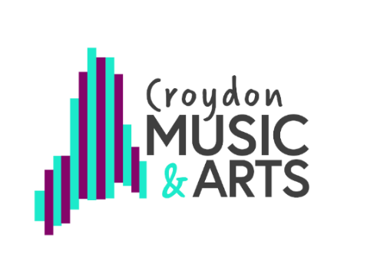
RSL Star Award (Star 4)

Assessment task: Research and share practice incorporating different traditions.

For Star Awards 1 to 3 you have been asked to research different cultural art forms, including something from your own heritage, something from Pop Culture, and a formal art tradition. For Star Award 4 you should research artists who have combined different traditions.

Here are some examples to get you thinking but talk to your teacher about other options.

Music: Research musicians who have composed or performed music from different cultures, often referred to as Fusion Music. Here are some examples from BBC Bitesize: Afro Celt Sound System (Irish and West African traditional music combined with electric dance music); Nitin Sawhney (South Asian, Jazz and other worldwide influences). You could make your own fusion music by combining a melody (e.g. from classical or folk music) and altering it using rhythmic or melodic ideas from another genre (e.g. swung quavers, dance beats, South American or West African rhythms, notes from a blues scale or an Indian Raga).

Dance: Look at the work of Akram Khan. How has he merged kathak and contemporary dance together? How do these pieces link to his own mixed heritage?
Over Pina Bausch’s long career how has she merged different styles together? Read this article and react to how Pinas works are being reimagined. Pina Bausch’s ‘Rite of Spring’ Takes Root in Africa - The New York Times (nytimes.com)

Theatre: Nowadays, Kabuki theatre is produced in collaboration with authors and directors of contemporary plays, and there are performances of new plays based on manga and anime films. Many Kabuki plays are also being performed on a variety of stages and not just exclusively in Kabuki theatres. How does this differ to when Kabuki originated?

Artists:

Keep a record of what you did to show your teacher. It could be a written account, a drawing or poster, set of photos, video, or audio description.

