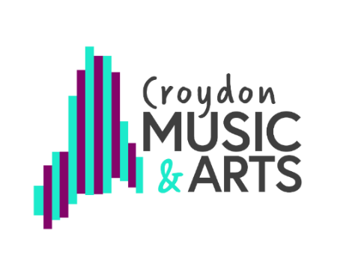
RSL Star Award (Star 5)

Assessment task: Research a contemporary artist

Research someone, or a collective (group of people working together on the same artistic project). A contemporary artist is someone who is pushing the boundaries of existing genres or creating their own new genre.

Here are some examples to get you thinking but talk to your teacher about other options.

Music: Music technology is evolving at a fast pace. Have a look at how different musicians are creating music with computers, or incorporating technology into an existing genre. How have DJs, DAWS and AI changed the way people make music? Or, you might look at a contemporary artist who is composing music for traditional instruments, including the voice. Ana Meredith is a well-known British composer who has explored a lot of these areas.

Dance: Look at the work of Merce Cunningham, how have his collaborations changed the way we see Dance as an Artform? Who is pushing the boundaries of Dance now? Who is incorporating other art forms into their work? How does classical Ballet use Pop Culture to widen its audience?

Theatre: What impact has Lin Manuel Miranda had on modern theatre. How and why has Hamilton captured the hearts of the world? Is he bringing a different audience to theatres? How are productions using celebrities to fill their audience? Is this is good thing for theatre, or does it make a mockery of actors who have trained for years?

Artists:

Keep a record of what you did to show your teacher. It could be a written account, a drawing or poster, set of photos, video, or audio description.

