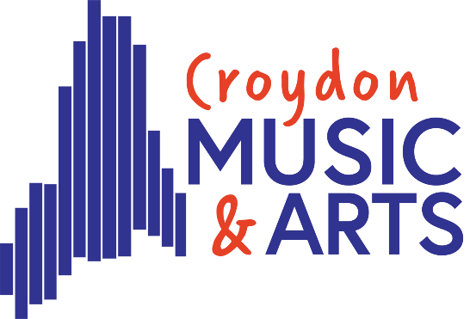

**Tuesday Centre**

Welcome Back

Dear Parents,

I’m looking forward to welcoming the Tuesday centre students back this **Tuesday 29th April.**

The majority of our time this term will be spent working towards our Showcase at Fairfield Halls on Tuesday 1st July. We have some exciting pieces planned for you to enjoy. Hopefully it will be our best one yet. This year’s theme is Partnerships, and as you already know, we have a massive partnership with Multi-story Orchestra this year.

Thank you so much for the support you have given to your child to take part in CMA activity this past year. We do understand that your child may be going through an examination session this term. For some, this may mean attendance could be sporadic while dealing with exam pressures. We totally understand this but would like to highlight the importance of hobbies and breaks during this stressful time. Coming to CMA might be just what is needed?

Due to our showcase, we will not be having a Tuesday concert this term, however we are joining forces with Friday centre to give any student the opportunity to perform a solo or small group piece they have prepared at the Friday centre concert. If your child would like to be a part of this, please ask them to speak to me in the next few weeks.

Jazz Band and Rockshop also have some separate shows this term. If your child is involved, you will be contacted separately by the band leader.

Key dates for this term are as follows

**Start date – Tuesday 29th April**

**Showcase Rehearsal – Saturday 28th June 9am-3pm (Tuesday centre needed 12:45-3pm)**

**Showcase – Tuesday 1st July – Tickets available soon**

**Friday/Tuesday Centre concert – Friday 4th July**

Here is the link to this year’s timetable. This will always be on our website to check if you are in any doubt of the centre dates.

[**Term Dates | Croydon Music & Arts**](https://www.croydonmusicandarts.co.uk/learn-with-us/term-dates/)

Showcase is on a Tuesday during term time. The rehearsals will start during the school day. I will send a letter closer to the time, for you to forward to your headteachers asking for the appropriate registration code to be used for their absence. Most headteachers are very supportive of CMA and are happy to allow you to attend the rehearsal. I just wanted to flag this now, so you are aware they will need most of the day out of school and can make arrangements for this.

Please do not hesitate to email me if you have any questions. Thankyou in advance for all your support this term

Lucie Vezey

Assistant Head – Croydon Music and Arts

[Lucie.vezey@croydon.gov.uk](mailto:Lucie.vezey@croydon.gov.uk)

musicandarts.education@croydon.gov.uk