Welcome back - and a special welcome to new Future Talent students who are joining Star Classes. We are delighted to have you with us on Saturday mornings.

Rehearsal Dates

April 26 May 3, 10, 17 HALF TERM Jun 7, 14, 21, 28 *Jul 5 (concert)

*There will be no rehearsals on July 5 for groups not performing in the concert.

Showcase Concert on July 1, 7 pm at Fairfield

Groups performing:

* Junior Band, Junior Strings, Junior Keyboards and Guitars
* RockWorks, Access Music Makers
* Chamber Choir, Vocal Stars, Percussion Stars, Creative Music Makers
* Intermediate Strings, String Orchestra
* Concert Band

There will be a rehearsal in Fairfield on the morning of July 1.

Saturday Centre Concert on July 5, 11.00 am at Oasis

Groups performing:

* Star Classes Violin, Cello, Clarinet, Brass, Guitars, Keyboards
* Percussion, Dance, Drama Stars, Vocal Stars

Rehearsals will start from 9.15 am in the morning, further details to follow.

Sharings

Following the success of last term’s Sharings we would like to invite you to come to see your children’s classes on these dates:

May 10 Junior Classes at 9.40

May 10 Intermediate Strings, String Orchestra, Concert Band at 11.55

May 17 Star Classes at 9.40

June 7 Vocal, Dance and Percussion Stars at 10.40

CYM entrance and exit

Our entrance is on Shirley Road, by the library. **We do not allow children to leave without an adult unless I have been given written permission from a parent or carer.**

Find out where to meet your child after their last activity by looking at the attached list of rooms.

Contacts

dee.elliott@croydon.gov.uk /musicandarts.education@croydon.gov.uk

CYM phone: 07715 239438

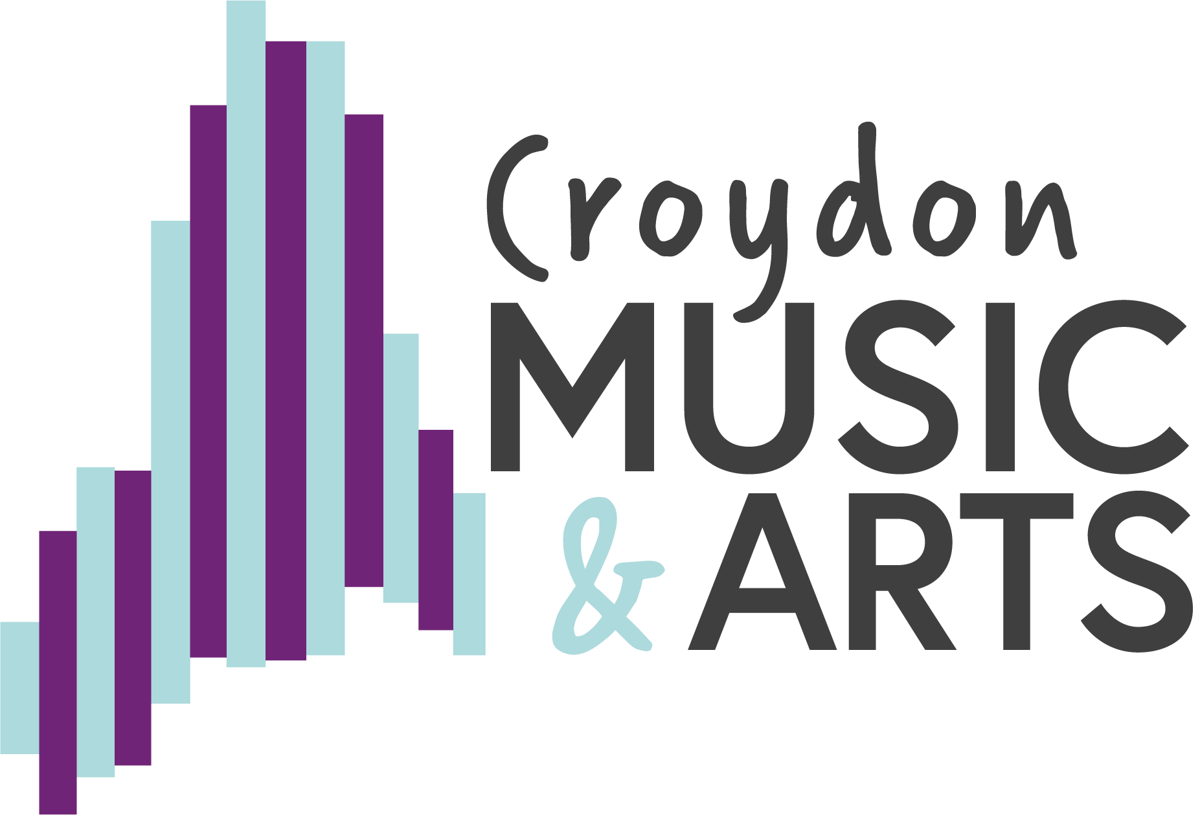

**CMA Saturday Centre April 2025**

]