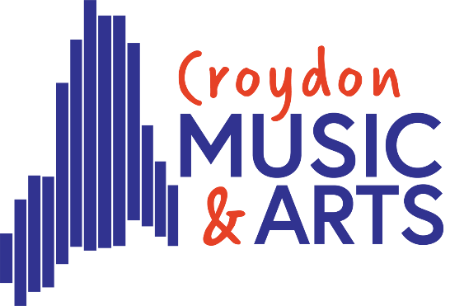
Tuesday Centre

Welcome Back, Happy New Year!

Dear Parents,

I’m really looking forward to welcoming all the Tuesday centre students this Tuesday 13th January.

CHANGES

We have had to make some changes this year to our class structure. Sadly, we will not be running Song Writing and Acoustic Band this term. The numbers in the class have made it financially impossible to run. Everyone affected has been contacted, if you have not received an email telling us about your preferences for this term, please do get in contact. We will keep a waiting list open with a view to restart in Summer term, numbers permitting.

TIMEKEEPING

Please can I ask all parents and independent students to make sure students are on time to sessions. We all know things like traffic can hinder our journeys, especially when Palace play, however there are a few students arriving outside of centre times which can be very frustrating for staff. After 15 minutes of the class starting there will not be anyone in reception to sign you in. After that time, you will need to Buzz on the main door and someone will be there to let you in.

NEW CLASS RUNDOWN

If you have any children in years 5-9, please do let them know we are offering a new music tech class on a Thursday 4:30 to 5:30pm with our very own Mr Hewitt Brown. Students will learn how to use ipads to create and produce music. Technology is so important to music production, and we want to develop this at CMA over the next few years. This class has been made possible by the new equipment CMA has been able to buy with the capital grant fund. We now have a whole class set of ipads that will be used in Croydon schools this year!

CONCERTS

We are very lucky this term to be having our end of term concert at Fairfield Halls. This will be on Tuesday 10th March at 7pm. We will be sharing the stage with Friday centre so if your child is in both centres that is a win! We will then spend the last 2 weeks of the term preparing for our Summer Showcase. More to follow on that later!

Please can I remind all parents to update their child’s medical records on speed admin. If you have any difficulty doing this, then please send anything you would like added to the main office. You can do that on this email address musicandarts.education@croydon.gov.uk. We really need this from you if your child has some sort of SEND need. We cannot support them, if we are not aware of their needs. Thankyou so much for your help with this.

Key dates for this term are as follows
Start date – January 13th
End Date – March 24th
Concert Date – Tuesday 10th March – 7pm
ONE WEEK HALF TERM – 17nd Feb– NO CENTRE

Please do not hesitate to email me if you have any questions.

Please make sure you are following our social channels so you can help us share the good work we are doing in Croydon. The centres will only survive if we have children attending them.

Thankyou in advance for all your support this term.

Lucie Vezey

Joint Head of Service – Croydon Music and Arts
Lucie.vezey@croydon.gov.uk
musicandarts.education@croydon.gov.uk

