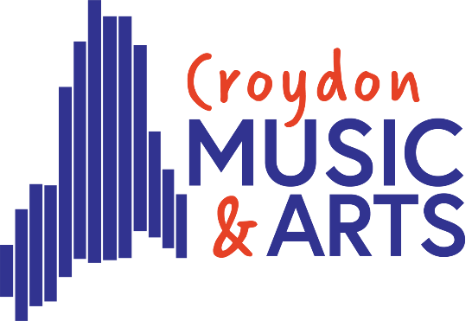
Tuesday Centre

Welcome Back

Dear Parents,

I’m looking forward to welcoming the Tuesday centre students back this Tuesday 14th April.

The majority of our time this term will be spent working towards our Showcase at Fairfield Halls on Tuesday 7th July. The rehearsal for the concert will be on Saturday 4th July at Oasis Academy. As Tuesday centre is quite involved in the showcase, please can I ask that these dates are added to family calendars as I know the end of the summer term can be busy.

Thank you so much for the support you have given to your child to take part in CMA activity this past year. We do understand that your child may be going through an examination session this term. For some, this may mean attendance could be sporadic while dealing with exam pressures. This is difficult when we have a showcase to put on. To try and combat this we have given a 3-week break at half term so everyone has time to revise. I have included the dates below as a reminder

Tuesday Centre Dates
April 14, 21, 28 May 5, 12, HALF TERM (3 Weeks) June, 9, 16, 23, 30

We totally understand that exams are so important but would like to highlight the importance of hobbies and breaks during this stressful time. Coming to CMA might be just what is needed?

Due to our showcase, we will not be having a Tuesday concert this term, however we are joining forces with Friday centre to give any student the opportunity to perform a solo or small group piece they have prepared at a joint Tuesday and Friday centre concert. If your child would like to be a part of this, particularly if this is their last term at CMA, please ask them to fill out the following form 10th July Tuesday & Friday Centre Concert – Fill out form
Rockshop also have some separate shows this term. If your child is involved, you will be contacted separately by Mr Holland.

IMPORTANT: Safeguarding and Health & Safety Update
Please read carefully – action required
With the introduction of Benedict’s Law in September 2026, Croydon Music and Arts (CMA) is reinforcing its commitment to safeguarding and health and safety to ensure the highest level of care for everyone who attends our provision.
All CMA staff receive regular safeguarding training, and qualified first aiders are always on site. To support this vital work and ensure we can respond effectively in an emergency, we require all families to complete the following actions:
What you must do
- Log in to your child’s Speed Admin profile immediately and check that all SEND and medical information is accurate and up to date.
(If you need support with this, please contact the office.)
- Ensure at least two emergency contact numbers are listed on Speed Admin.
If we cannot reach you in an emergency, we must be able to contact an alternative trusted adult without delay.
- If your child carries an EpiPen, please email lucie.vezey@croydon.gov.uk to arrange a short but essential discussion about how CMA will safely support its use.
Safeguarding contacts
Our Designated Safeguarding Leads (DSLs) are:
- Lucie Vezey – lucie.vezey@croydon.gov.uk
- Izzy Fixter – isabel.fixter@croydon.gov.uk
If you have any safeguarding concerns or questions, please contact one of the DSLs as soon as possible.
Thank you for your cooperation in helping us keep all children and young people safe.

Key dates for this term are as follows
Start date – Tuesday 14th April
Showcase Rehearsal – Saturday 4th July 9am-3pm TBC
Showcase – Tuesday 7th July – Tickets available soon
Friday/Tuesday Centre concert – Friday 10th July
Here is the link to this year’s timetable. This will always be on our website to check if you are in any doubt of the centre dates.
Term Dates | Croydon Music & Arts
Showcase is on a Tuesday during term time. The rehearsals will start during the school day. I will send a letter closer to the time, for you to forward to your headteachers asking for the appropriate registration code to be used for their absence. Most headteachers are very supportive of CMA and are happy to allow you to attend the rehearsal. I just wanted to flag this now, so you are aware they will need most of the day out of school and can make arrangements for this.
Please do not hesitate to email me if you have any questions. Thankyou in advance for all your support this term

Lucie Vezey

Assistant Head – Croydon Music and Arts
Lucie.vezey@croydon.gov.uk
musicandarts.education@croydon.gov.uk

